Module 2 Assignment: Exploratory Data Analysis

1. State the problem described by the client & desired outcomes.

The client is the Regional Manager of Western and Northern Michigan McDonald’s franchises whose requirements are as follows:

* Understand the reason for loss in customer traffic per year over the past 3 years
* Did the All-day breakfast promotion boost sales?
* Should the All-day breakfast promotion be continued or pulled off?
* Was the decision to choose McMuffin the right choice as compared to biscuit sandwiches or both items?
* Which products are preferred at different times of the day by different demographics across the various franchisees? Are the cheaper items preferred in certain areas at certain times?
* What would be advisable to get new customers?

The desired outcomes by the client are as follows:

* Identify the root cause for the consistent loss of customers over the last 3 years.
* Identify if the All-day breakfast promotion increased traffic when released
* Are the All-Day Breakfast items popular post breakfast time?
* Should certain items of the menu or All-Day breakfast menu be altered or improved or removed?
* What are the revenues looking like pre and post All-Day Breakfast promotion and how is the revenue performing in the current marketplace?
* How can the current marketing strategy be improved to increase foot traffic and sales?

1. Describe your hypothesis identifying the business drivers (influences).

From the data given by the Regional Manager, I categorized and identified the below factors in the data which could possibly have an effect on the business:

|  |  |
| --- | --- |
| INTERNAL FACTORS | EXTERNAL FACTORS |
| Operations like workflow, staff, equipment | Customer satisfaction |
| Location of restaurant | Competitor’s position in the market |
| Marketing strategy | Economy |
| Sales rate | Population of county |
| Weighted average price per item sold | Consumer habits |

1. On creating a histogram of the total units sold over the ethnicity and income of each county, I identified that General Consumer Market (GCM) is the highest consumer across all the countys and there isn’t enough information about the remaining ethnicities to understand if it is a business driver. Therefore, I believe that ethnicity is not a business driver here, however I did see that the consumer income-wise was leading in the mid-income and 2nd Lowest income areas across the countys with people with the highest incomes consuming the least.

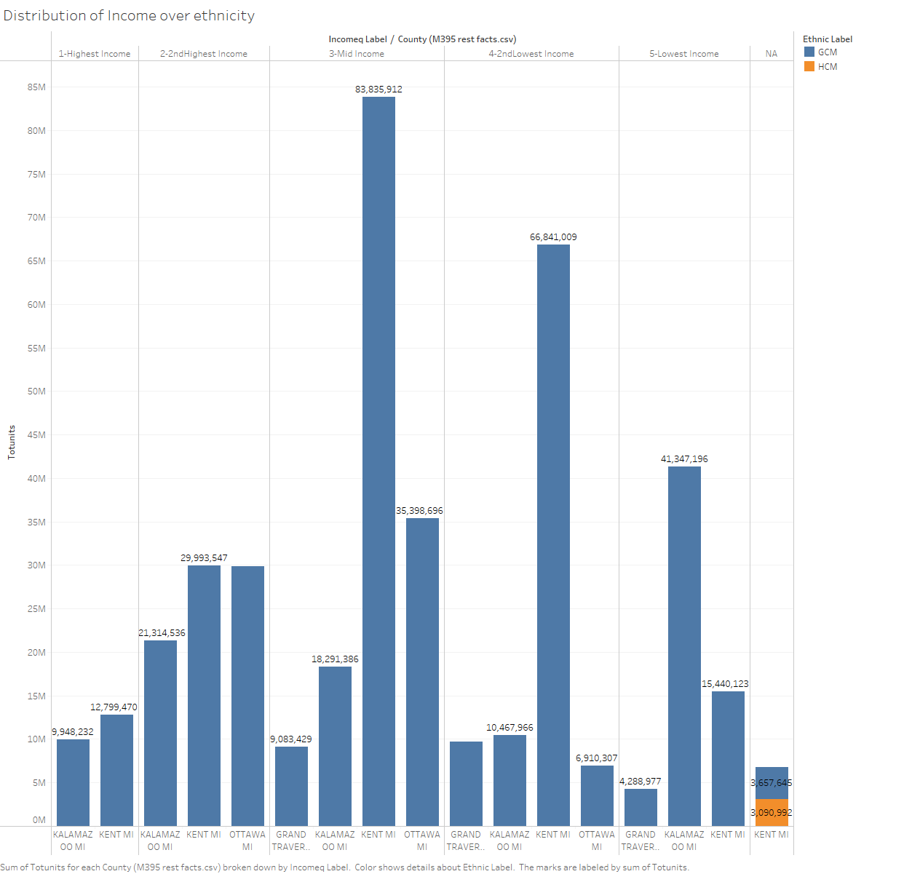

1. I then looked at the total units sold per County over each restaurant type and identified that the freestanding restaurants are the maximum over the region with special restaurants driving a large point of the sales. Thus, the type of restaurant is not a good enough business driver to enable in identification of customer traffic or sales generation.

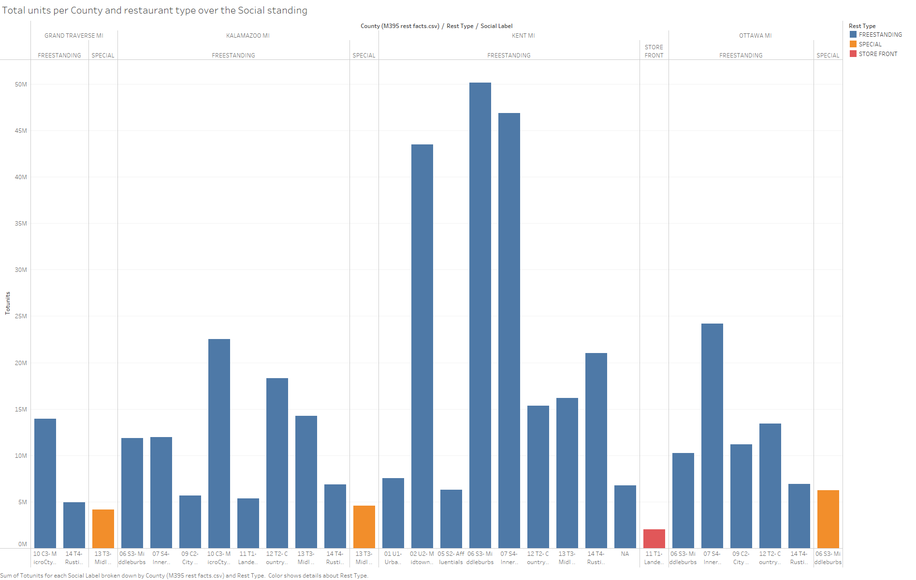

1. The social standing of the people within a county can be considered as business driver similar to income however the distribution of restaurants is a factor to be considered in this scenario.
2. Total units sold per County does provide good information of which county is performing better.

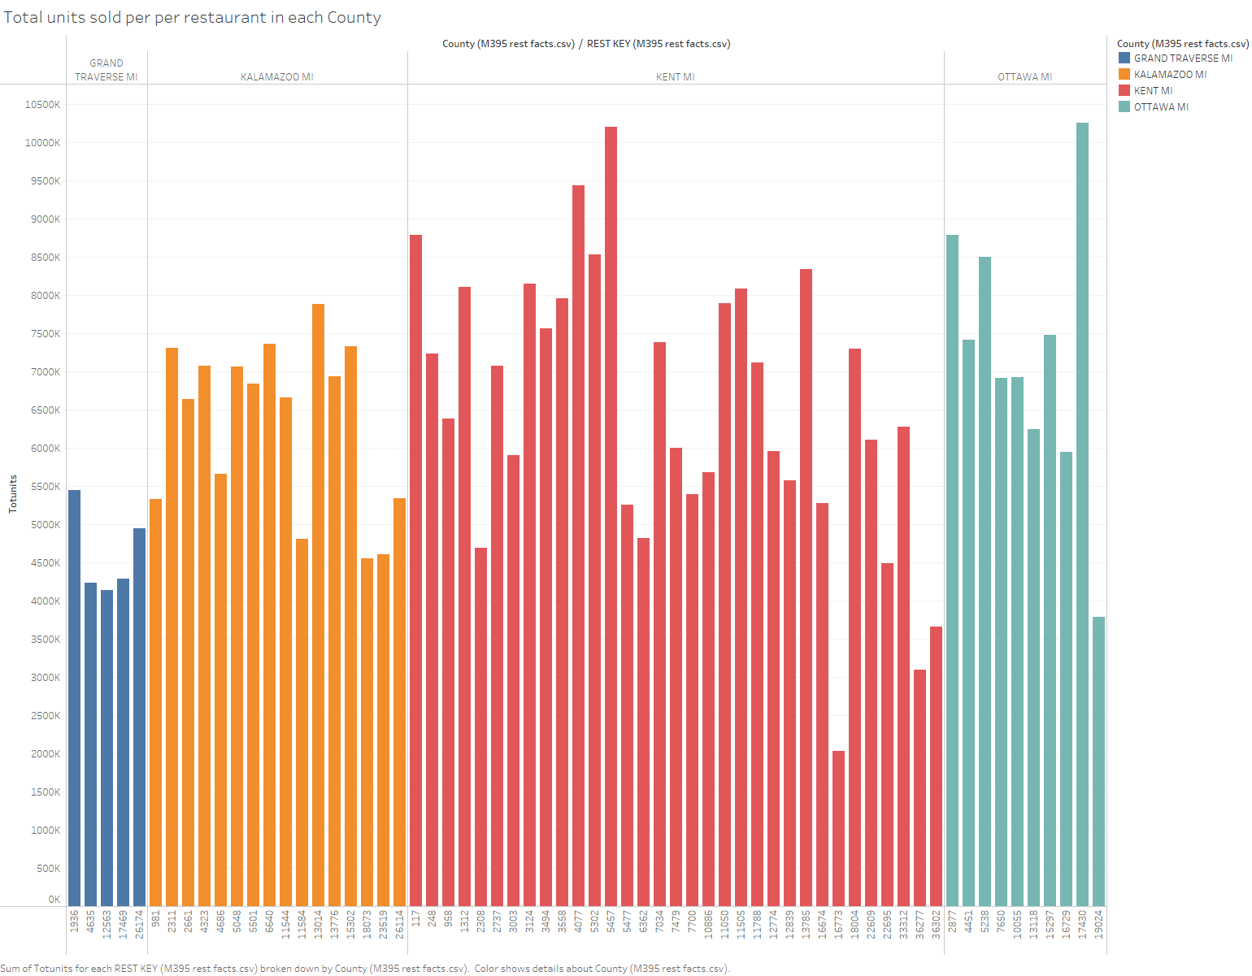

1. The weighted Average price does affect the total units sold per week especially when comparing the breakfast items separately and comparing the standard deviations of the weighted average price against different items.

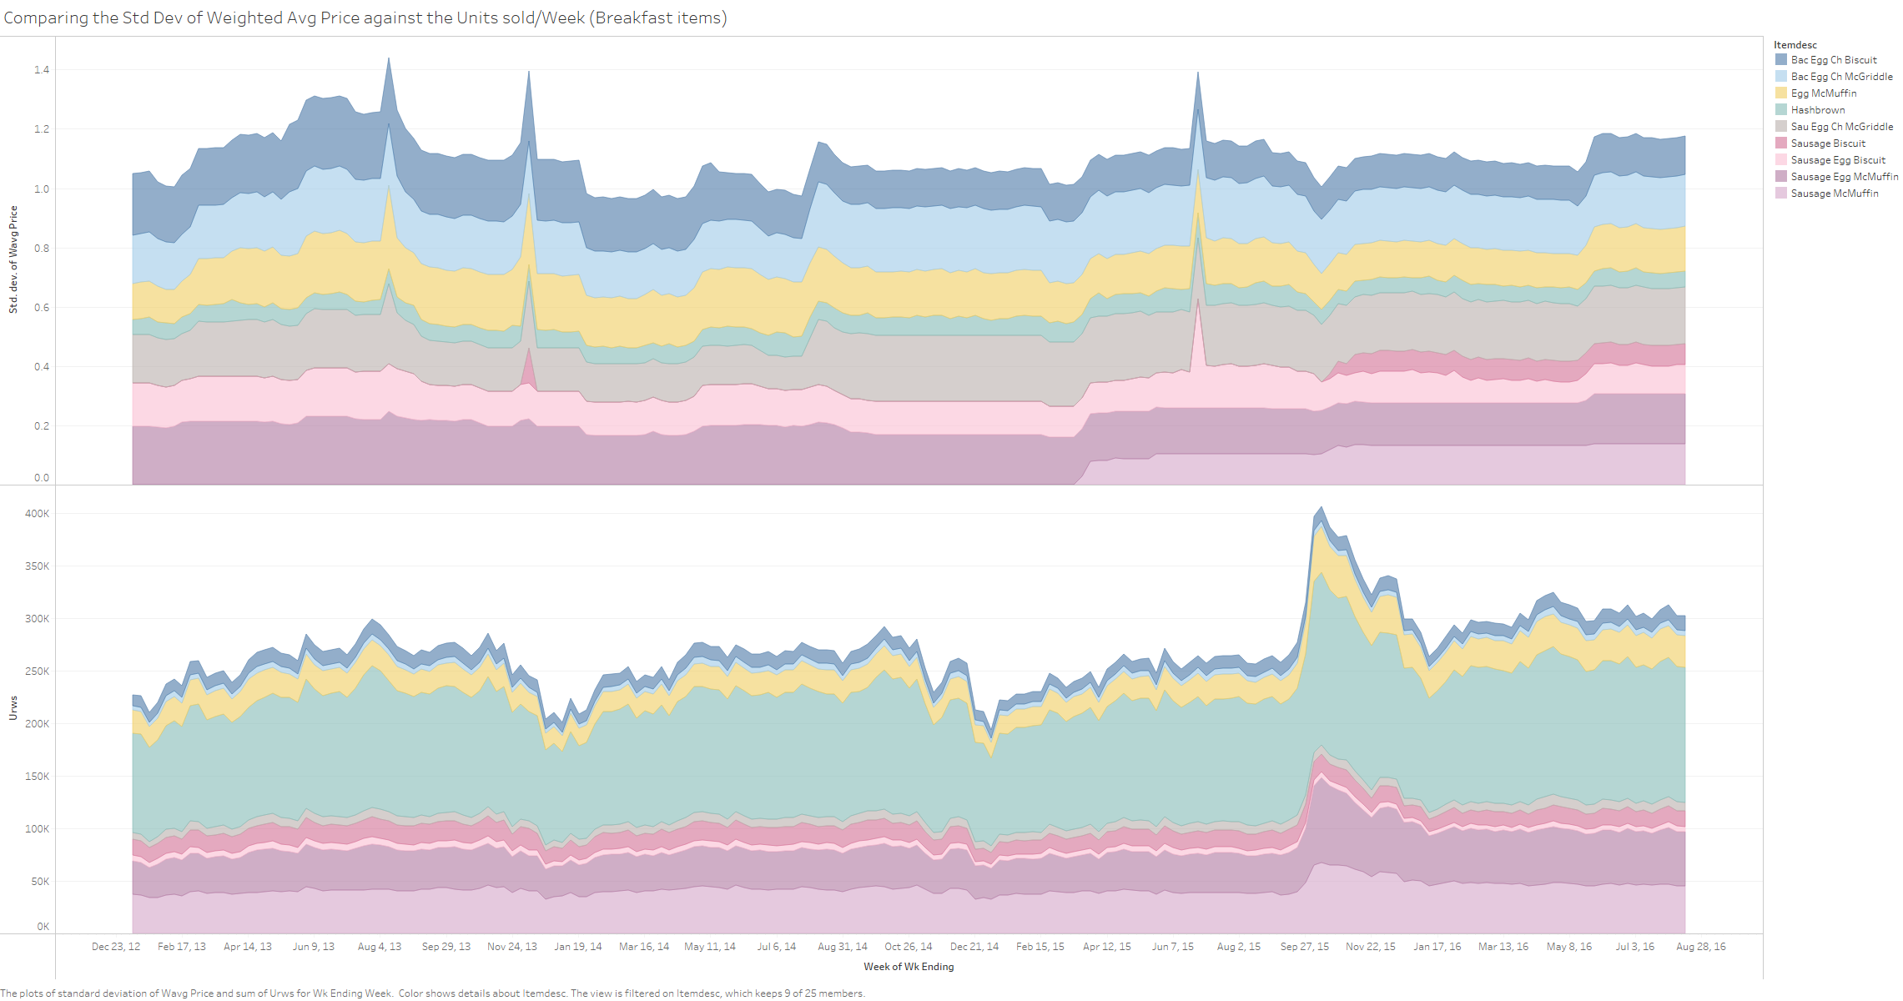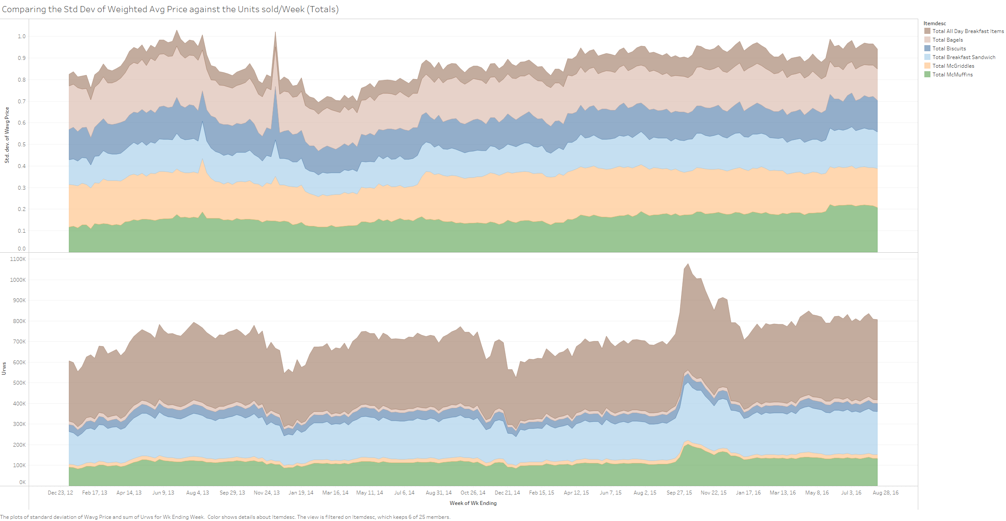

1. The population of a county and the spread of income does help in understanding if it is driving the sales of the restaurant.
2. Identify variables available that relate to business drivers.

The variables I identified that relate business drivers are below;

1. Totunits = Number of units sold per week
2. County, Rest type – location of the restaurant
3. Rest Key – identify units sold per restaurant
4. Itemdesc – Identify which items sold more over the menu
5. Year of Wk Ending – to identify quarterly sales county wise
6. Wavg Price and Urws – to identify how the weighted average price affected the weekly transactions for specific breakfast items
7. Income q label, Social label – identify the income and type of people leading to more traffic in the restaurants per county.